6th March 2018

**YOKOHAMA to Begin Overseas Sales of iceGUARD iG60, the Ultimate YOKOHAMA Studless Tyre**

YOKOHAMA will begin sales of “iceGUARD iG60”, the latest addition to its “iceGUARD” series of studless tyres (Nordic friction tyres) for passenger cars, on overseas markets from this autumn. Product releases will be carried out in stages, starting with Northern Europe and Russia, which are core markets for the “iceGUARD iG60” and gradually spreading to other markets in Asia and Europe. The “iceGUARD iG60” will be available in a total of 102 sizes, ranging from 265/35R19 94Q to 135/80R13 70Q. The Company also plans to gradually expand the line-up of available tyre sizes. The “iceGUARD iG60” was introduced in Japan as the “iceGUARD 6” in September 2017.   
  
In addition to the “iceGUARD” basic concept’s three core traits of “ice efficacy”, “long-term efficacy” and “fuel efficiency,” the “iceGUARD iG60” has been endowed with a new fourth merit – wet performance, or “wet efficacy”. Development of the “iceGUARD iG60” aimed at raising the tyre’s wet performance as well as sharply enhancing braking on ice – the most crucial performance feature of a studless tyre.   
  
The iceGUARD iG60’s tread design features an asymmetrical pattern with the inside designed to improve performance on ice while the outside tread pattern is designed for optimal performance on snow. The inside tread pattern improves the tyre’s grip on icy surfaces by enhancing the edge effect and expanding the tyre’s contact area with the road surface. In addition, newly developed double micro grooves deliver optimum ice performance from the instant the tyres are fitted on the vehicle, while its Quattro 3-D Dimple Sipes increase the tyre’s rigidity and enhance its steering stability.   
  
A newly developed premium absorptive compound is used in the tread compound. Absorptive micro balloons are dispersed evenly throughout the rubber, improving its ability to absorb water on the icy surface, the main reason for slippage on ice. In addition, the amount of silica compound has been increased and supplemented by the first use of a silica highly reactive white polymer, which promotes uniform dispersion of the silica and raises the tyre’s ability to adhere to the surface, thereby improving its performance on icy and wet surfaces. The compound’s use of Orange Oil-S, developed specifically for use on studless tyres, keeps the tyres soft and pliant even after the typical deterioration of the rubber that occurs with age and use, thus extending the useful life of the tyre’s performance on ice. These new technologies increase the tyre’s ice performance by 15% over that of the previous product (iceGUARD iG50 PLUS) and its wet performance by 5%, while also securing higher levels of performance sustainability and fuel efficiency than achieved with the previous product. Pattern noise and road noise have also been sharply reduced in order to deliver a quieter ride.

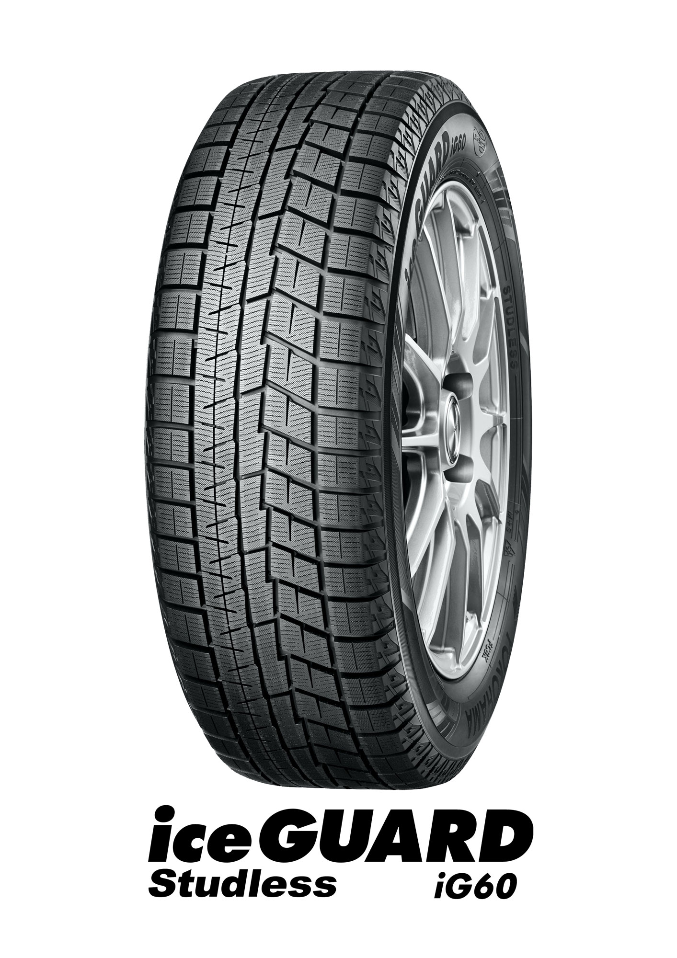

*iceGUARD iG60 Studless*

##### Asymmetrical Tread Pattern Further Enhances Ice Performance

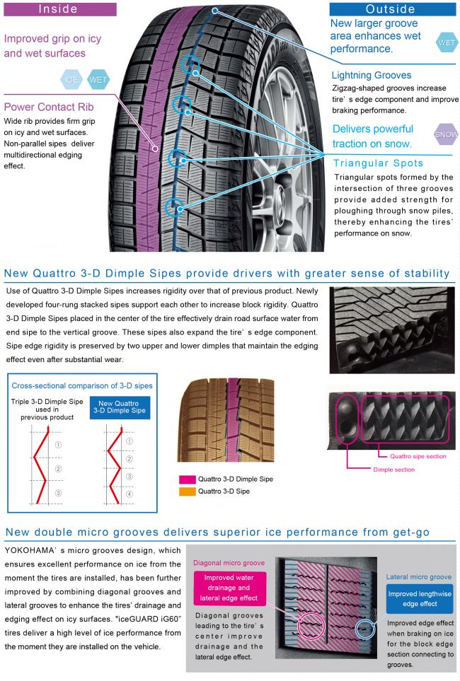

##### New Compound Enhances Performance on Icy and Wet Surfaces

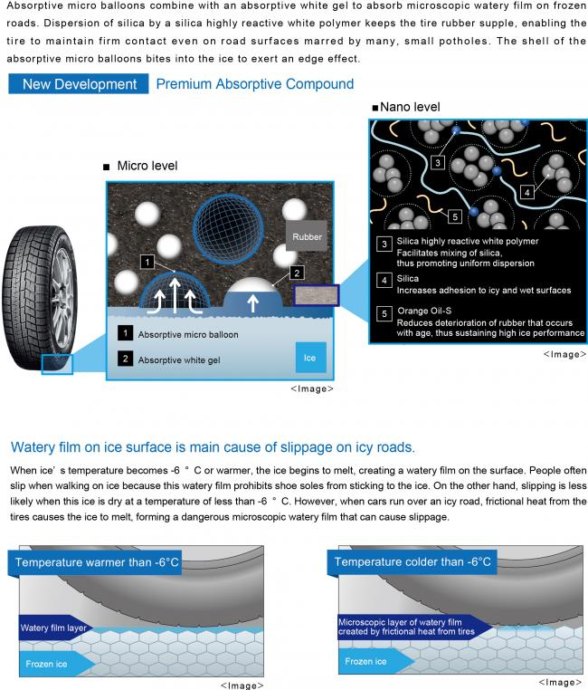

##### Available Sizes

